Sermon Case Presentations

Presenter:

Observer:

**What you felt while listening to the sermon:**

Body sensations:

Feelings:

Thoughts you noticed popped up:

Moments you felt the holy spirit nudge you in a direction (say more, say less, go here, go there, this person needs to hear this, etc.):

**Places you noticed an urge or desire to join or disconnect:**

**Trauma language used:**

**Places you noticed pendulation:**

**What crisis was presented in the sermon?**

Developmental?

Life crisis?

Psychological crisis?

Theological crisis?

Relational crisis?

How did your colleague address that crisis theologically? And from a trauma/crisis intervention perspective?

Were there metaphors you noticed in the sermon that could help the listener move the trauma through the stages of healing? What were they and how did you see them being used to address safety, stability, grief, or reconnection?

How did the sermon help the listener tap into an aspect of the Hero’s Journey?

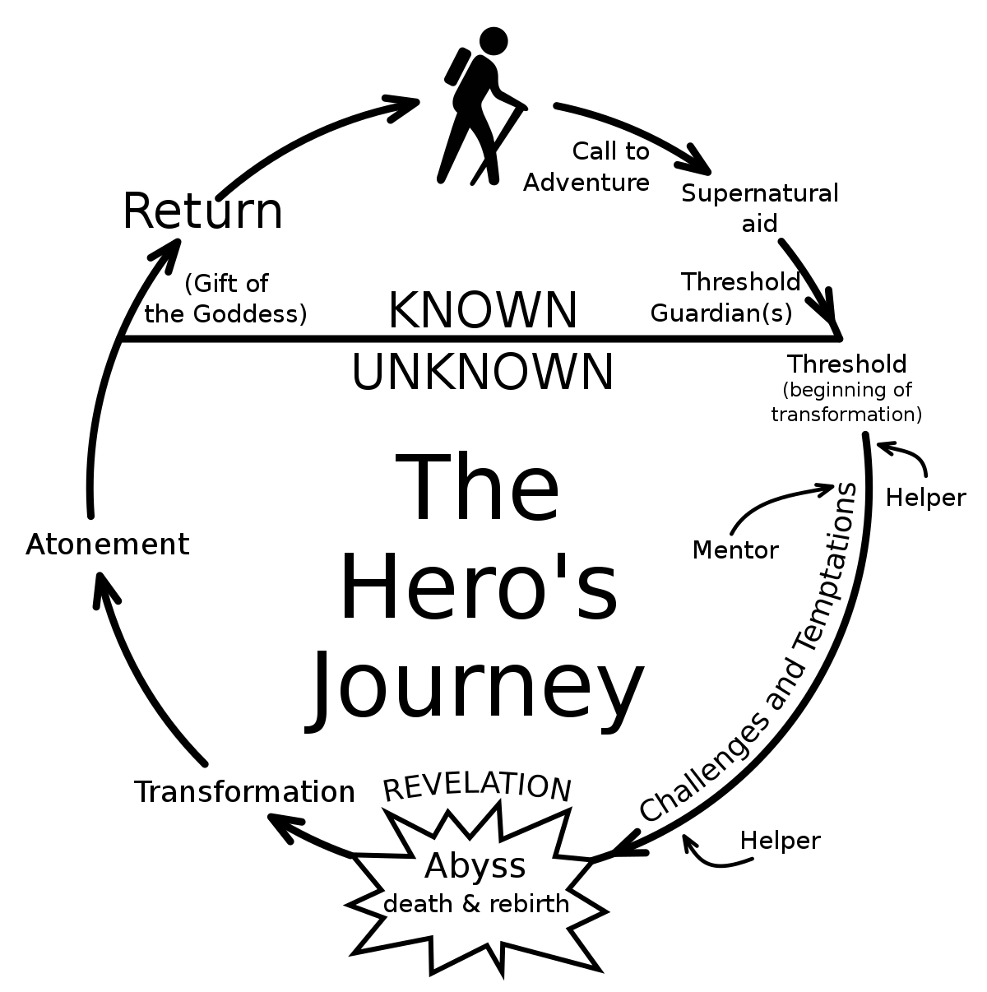

How were the use of rituals helpful? If not used during the sermon, are there rituals you can think of that would have helped moved the message toward something healing? Safe and sacred?

Something that you really liked in your colleague’s presentation: