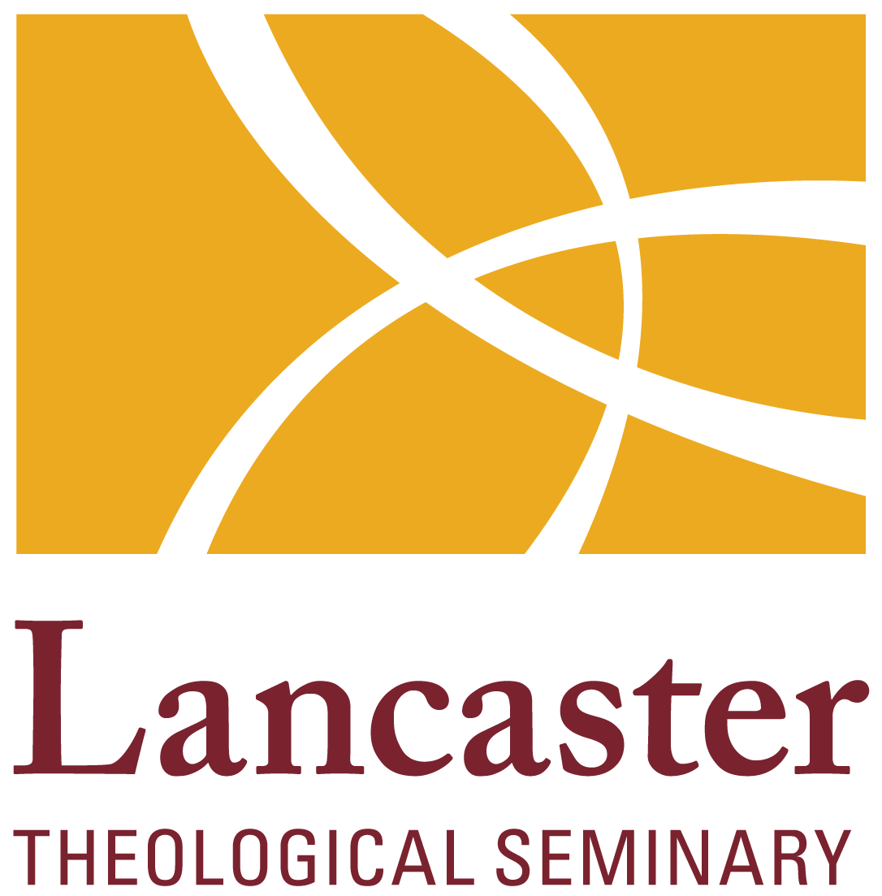
Crisis Intervention and Trauma

PT350WH Syllabus

Term 1 and 2021

August 20 – October 22, 6:30-9:30 pm Friday evening

Instructor Information
Name: | Dr. Stephanie Van Deusen
Email Address: | svandeusen@lancasterseminary.edu
Office Location: | Lark 202
Office Hours: | By appointment

Course Description
This elective course examines the phenomena of clinical crises and emergencies, as well as intervention strategies. Attention will be paid to specific types of crises such as suicide, relational losses such as divorce or breakups, sexuality, substance use disorders, domestic violence, racial trauma, sexual abuse and PTSD in order to increase students understanding of the developmental, psychological, and cultural dynamics driving the crisis. The course will help students assess the individual in crisis as well as the larger system dynamics. The course will provide a very concrete model to practice during the class so the student can apply their new knowledge in a practical way.

Together we will explore how to work with the spiritual elements of crisis and trauma within a trauma-informed framework. Moving beyond specific crises or emergencies, this course will also look at how to facilitate a healing process for collective, intergenerational and cultural trauma. Students will work with their colleagues to develop a pastoral perspective to bring into their specific area of pastoral care.

Course Learning Objectives
To provide conceptual framework for understanding trauma and the process of healing.
To familiarize students with the resources and experts in the field of traumatology.
To provide a conceptual framework for a trauma-sensitive theology.
To discuss the intersection of attachment-based trauma and spiritual injury, including issues such as attachment to God, image of God, and faith development.
To provide conceptual framework for understanding specific types of crisis.
To gain understanding on how to assess, intervene, and follow up with individuals in crisis.
To understand the impact of human diversity including age, gender, sexual orientation, race, religion, ethnicity, and culture when working with pastoral issues related to traumatic stress.
To discuss the ethical and professional issues related to working with persons presenting with trauma-related issues, including factors related to cultural competence, rapport and relationship building, appropriate boundaries and empathy, countertransference and self-care.

Degree Goals and Outcomes
These course objectives contribute to the following degree goals and outcomes:
Demonstrate awareness of a trauma-informed theology and psychology that will enhance the pastoral practitioners ability to effectively understand and intervene with a person presenting with trauma-related issues and/or crises.
Apply interventions to specific types of crisis, including assessment, rapport building, intervention, and ways to follow up.
To develop critical skills for theological analysis of and creative engagement with current challenges and changes in the church and the world.

To cultivate a willingness to lead, sustained via ongoing vocational discernment, self-awareness, and accountability with partners in ministry.

To critically engage matters of faith, justice, and human difference in local and global contexts.

Course Engagement with Diversity
Lancaster Theological Seminary intentionally challenges students to lead in a diverse world where there is an increasing need for leaders who have the capacities to encounter complexity, listen thoughtfully, and lead from places of authentic self-awareness and theological integrity. In this course, this will occur in multiple ways:
The course material will help student’s demonstrate an understanding of how the their own personal/cultural history, attitudes, and biases may affect how they understand the impact of cultural trauma, transgenerational trauma, and personal crisis.
Students will be asked to research a specific collective trauma and its impact on the healing process. Students will facilitate a conversation with their colleagues that addresses issues such as intergenerational trauma, symbols, language, metaphor, experiences around values and beliefs, and sense of self and space.

Course Policies

Inclusive and Expansive Language
Language both mirrors and constructs social reality, often intentionally or inadvertently determining who is included and who is excluded from important conversations. For this reason, Lancaster Theological Seminary promotes the use of inclusive language. For our purposes, inclusive language is language that promotes a diverse and just environment for all in which the broadest possible range of people are represented and included in communal conversations. This includes such matters as language about God, humanity, cultures, nationalities, ethnicities, races, and religions, with regard to such characteristics such as sex, gender, sexual identities, social class, age, and differing abilities. See Appendix III of the Student Handbook for more guidance on the use of inclusive and expansive language.

Statement of Standards
Lancaster Theological Seminary students act in all academic and Seminary matters with the utmost honesty and integrity. They conduct themselves professionally and responsibly in order to promote a community of trust and respect. These fundamental values inform and support the Seminary’s commitment to honoring diversity, creating and nurturing community, and upholding academic excellence.
Breaches of the Seminary’s Standards for Academic Integrity include but are not limited to:
- Cheating on examinations and papers;
- Plagiarism, including but not limited to:
  - Misrepresenting the nature and extent of one’s own research;
  - Offering work done by others as one’s own;
  - Employing words and/or ideas originating with others without proper acknowledgement; and/or
  - Submitting the same work for more than one course without clear and prior consent of all instructors.
Any student suspected of violating the standards of academic integrity will be reported to the Dean of the Seminary. Standards Committee procedures are found Section 9 of the Student Handbook.

Style Guide for Written Work
The faculty has adopted as the standard guide to writing papers for all programs the following handbook: Kate L. Turabian, A Manual for Writers of Research Papers, Theses, and Dissertations: Chicago Style for Students and Researchers, (Chicago: University of Chicago Press). All students are urged to purchase this handbook. It is based on The Chicago Manual of Style. Preference will always be for the most recent edition in publication at the start of the academic year. Copies of the Turabian text and the Chicago Manual of Style are also available in the Library. Access to the Chicago Manual of Style Online is provided through your library account.

Intellectual Property Rights of Students
The Seminary recognizes that individuals enrolled in a Seminary course retain ownership and rights over the work they create while enrolled in that course. In compliance with our accrediting bodies, one assignment from each student in every course will be collected and stored for later assessment of the Seminary’s degree programs. These samples of student work will not be used for any other purpose and will be destroyed when the assessment period is complete.

Classroom Etiquette
The use of recording devices during class should be arranged with the professor before class begins. Eating during class should be limited to break times. Cell phones must be turned off or silenced in the classroom while class is in session. A student who must receive or make a call should leave the classroom before doing so.

Zoom Classroom Etiquette
Plan to join the Zoom meeting room at least three minutes before class is scheduled to begin. Mute your microphone or telephone unless you are speaking. Use a headset or headphones to minimize feedback and echoes. When your camera is on, refrain from eating, loafing, leaving your desk, grooming habits, and making distracting movements. Let the professor know (via chat) if you need to turn off your camera for any reason, including a poor internet connection or the need to engage in any of the above activities. Use the chat feature to ask questions and/or report technical difficulties.

Academic Accommodations
See Appendix II of the Student Handbook for the Seminary’s services for students with Disabilities. Students are responsible for scheduling appointments with individual professors whose classes they are enrolled in once they have received their Education Accommodation Plan (EAP). Students are encouraged to contact professors to request a convenient time to have a full discussion about their specific disability, their concerns in being able to fulfill the requirements of the class, and what both the student and professor are willing to do to help accommodate them. Each professor will also receive a copy of the EAP detailing the approved accommodations for that specific student.

Class Attendance
Students are expected to attend every class session in its entirety. Attendance is taken at every class session. Absences may be taken into consideration in evaluating the student’s total contribution to the work of the course. You are responsible for consulting with the professor about the best means for making up work missed due to absence. Normally, missing more than 20% of class sessions will result in failure of the course. This applies to all absences, whether “excused” or not.
Acceptable indications of attendance in an online course can include submission of work and posting in a discussion forum. Logging in to the course site is not sufficient, by itself, to count toward a student’s attendance or active participation in the online components of a course. Students who fail to adhere to the online attendance requirements risk failing the course.

Course Expectations

Workload
This class is meant to be a survey course that is thought provoking and reflective. Due to this being the first time this class is being taught I would estimate the time needed each week, including the time in the classroom would be 5 hours.

Assignments and Grades

Evaluated Area: Points of 100

Participation 25
Reflection Paper 1 15
Reflection Paper 2 15
Reflection Paper 3 15
Interview Response Paper/Handout 15
Project Oral Presentation 15

Grading Rubrics

Reflection Paper Rubric:

Answer key questions:

What was your first reaction to the material? Was it positive, negative, or neutral/
Has the material changed your mind in some way?
Which issues or questions were addressed in the material?
What issues or questions does the material fail to address?
What new or remaining questions do you have after reading/listening/viewing the material?
What have you learned from this material?
Does it remind you of an personal experiences, or anything else you’ve seen or read?

Identify a theme:

What’s the main takeaway?
Look at your responses and see if you can identify any common themes.
Identify how the material has affected you, especially if the material incites any strong opinions or reactions from you.

Make connections:

Reflect on how this material applies to role in pastoral ministry.
Reflect how this material connects or conflicts with your current theology.
Does the material remind you of any personal experiences you’ve had, or other books or films you’ve encountered?
Can you connect it to any current events or real-world examples?

Summarize:

Your reflection paper should not be just a mere summary of the material you’ve read or studied. However, you should give a recap of the most important aspects, and other specific examples when necessary to back up any assertions you make.

Late Submissions
Addressed on an individual bases.

Course Materials

Required Texts:

Kanel, K. (2019). A Guide to Crisis Intervention (6th Edition). Boston, MA: Cengage.

Hubel, T. (2020). Healing Collective Trauma. Border, CO: Sounds True.

Supplemental Texts:

Baldwin, J. (2018). Trauma-Sensitive Theology—Thinking Theologically in the Era of Trauma. Eugene, OR: Cascade Books.

Granqvist, P. (2021). Attachment in Religion and Spirituality—A Wider View. New York, NY: Guilford Press.
Langberg, D. (2015). Suffering and the Heart of God—How Trauma Destroys and Christ Restores. New Growth Press (1st Edition).

Mason, K. (2014). Preventing Suicide: A Handbook for Pastors, Chaplains and Pastoral Counselors. Downers Grove, IL: InterVarsity Press.

Menakem, R. (2017). My Grandmother’s Hands—Racialized Trauma and the Pathways to Mending Our Hearts and Bodies. Las Vegas, NV: Central Recovery Press.
`
Perry, B. & Winfrey, O. (2021). What Happened to You? Conversations on Trauma, Resilience, and Healing. New York: Flatiron Books.

Resources for Student Success
- Office hours individually determined.
- The Library offers an array of print and electronic resources and services to students, including course reserves, assistance with technology and research, and an after-hours access program. https://library.lancasterseminary.edu
- Writing Center coaches Frank Gray and Brian McDonald are available to assist with drafts, rewrites, and more. Contact writingcenter@lancasterseminary.edu.
- Educational specialist Beth Grimm is available to assist with academic accommodation or modification as needed. https://courses.lancasterseminary.edu/course/view.php?id=381&section=7.

Course Schedule
[Include a table or listing of each class session, the date it is scheduled, what preparation is required, and what assignments are due. The table below may be adapted or modified for this purpose.]

Class Date | Topic, Readings, and Assignments Due
Week 1 – 8/20/21 | Topic – Introduction: Trauma Theory  Exercise: Generational Trauma Lens  Assignment: Podcast: What Happened to You? Conversations on Trauma, Resilience, and Healing.  Assignment: Write 2-4 page reflection paper—Trauma-Informed Framework
Week 2 – 8/27/21 | Topic: Understanding the “Trauma Vortex”—Metaphor and science  Readings: Chapters 1-2 in Healing Collective Trauma text  Exercise: B. Brandt’s Mini Trauma Activity  Assignments: Write a 2-4 page reflection paper—The Impact of Trauma
Week 3 – 9/3/21 | Topic: Understanding the “Counter Vortex”—Attachment theory  Readings: Reading: Chapter 3 in Healing Collective Trauma text  Supplemental Reading: Granqvist, P. (2020). Attachment in Religion  Assignments: Write a 2-4 page reflection paper—Trauma, Attachment, Spirituality, and Faith Development
Week 4 – 9/10/21 | Topic: Crisis Intervention—Definition, Ethics, Model  Readings: Chapters 1-3 in A Guide to Crisis Intervention text
Week 5 – 9/17/21 | Topic: Crisis Intervention—Issue of Suicide  Readings: Reading: Chapter 4 in A Guide to Crisis Intervention text  Supplemental text: Mason, K. (2014). Preventing Suicide: A Handbook for Pastors, Chaplains and Pastoral Counselors.  Small Group Discussion: Topic or Triad Practice  Reflection Papers Due
Week 6 – 9/24/21 | Topic: Crisis Intervention—Developmental, Cultural Crisis, and Loss  Readings: Chapters 5 and 6 in A Guide to Crisis Intervention text  Small Group Discussion: Topic or Triad Practice
Week 7 – 10/1/21 | Topic: Crisis Intervention—Community Disaster, Trauma, PTSD  Readings: Chapters 7 and 8 in A Guide to Crisis Intervention text  Assignment Due: Interviews
Week 8 – 10/8/21 | Topic: Crisis Intervention—Sexual Trauma, Intimate Partner Violence
Week 9 – 10/15/21 | Topic: Crisis Intervention—Crisis Related to Sexuality, Substance Use  Readings: Chapters 10 and 11 in A Guide to Crisis Intervention text  Oral Presentations
Week 10 – 10/22/21 | Topic: Collective Trauma  Readings: Chapters 4-6 Healing Collective Trauma  Oral Presentations  Closing Ritual

